Heidelberg Catechism Question & Answer #1

Q. What is your only comfort in life and in death?

- That I am not my own, but belong body and soul, in life and in death, to my faithful Savior Jesus Christ. He has fully paid for all my sins with his precious blood and has set me free from the tyranny of the devil. He also watches over me in such a way that not a hair can fall from my head without the will of my Father in heaven; in fact, all things must work together for my salvation. Because I belong to him, Christ, by his Holy Spirit, assures me of eternal life and makes me whole-heartedly willing and ready from now on to live for him.
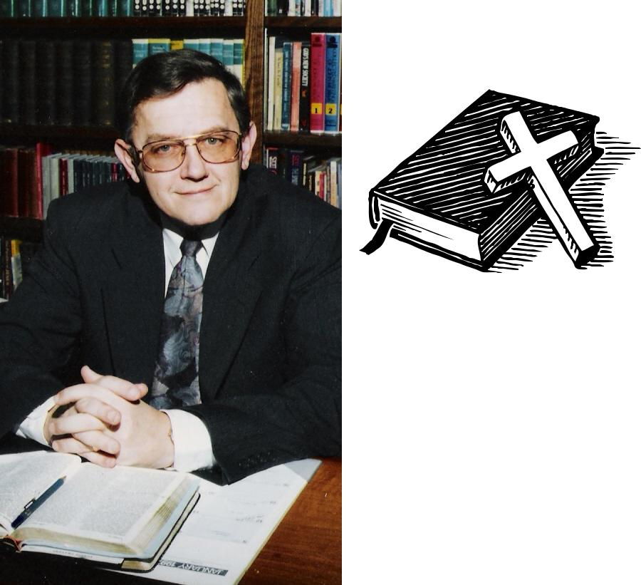

In Loving Memory

of

Reverend C. Eric Fennema
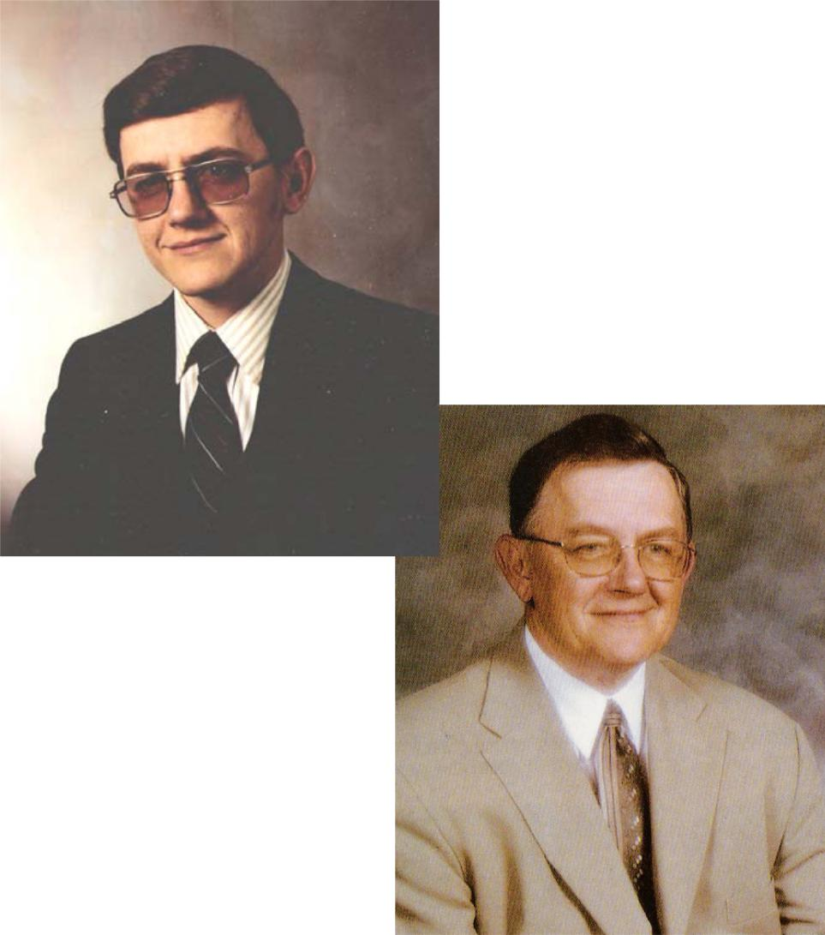

Service in ministry:

Jan. 14, 1975 - Sept. 6, 2008

Congregations served:

- Beacon Light, Gary, Indiana

- Sibley CRC, Sibley, Iowa

- Napa CRC, Napa, California

- First CRC, Rock Valley, Iowa

- Trinity URC, Lethbridge, Aleberta

“How beautiful upon the

mountains are the feet of him who brings good news, Who proclaims peace, Who brings glad tidings of good things, Who proclaims salvation, Who says to Zion, YOUR GOD REIGNS!” Isaiah 52:7

November 8, 1949 - September 6, 2008



Rev. C. Eric Fennema, beloved husband, father, grandfa-ther, minister of the Gospel and friend went home to the Lord on Saturday, September 6, 2008 at the age of 58. Eric was born in Roseland, Illinois on November 8, 1949, son of the late Clarence and Cecile Fennema. Eric's desire for ministry began early in life. God confirmed the call and he was ordained into the ministry on January 14, 1975. The Lord led Eric to many congregations during his 34 years of ministry. Eric's passion was for the Lord. He preached the Word of the Lord with conviction according to His almighty purposes. Eric urgently prayed for his family and others that they be right with the Lord; to have their faith in the Lord. Eric was preceded in death by his parents and a sister, Nancy.

Eric is survived by Helen, his loving wife of 37 years, five children, Anne (Scott) Hendrikse, Joel Fennema, Jonathan Fennema, Sarah (Jason) Van Voorst, and Caryn (Micah) Schouten; six grandchildren: Hannah, Mary, and Jacob Hendrikse; Mackinzie and Faith Van Voorst; and Alexa Schouten; two brothers: Roger (Carol) and Alan (Darlene); two sisters: Virginia Eizenga and Marcia (John) Hohm; and numerous nieces, nephews and friends.

Ps. 116:13-15 "I will take the cup of salvation, and call upon the name of the Lord. I will pay my vows unto the Lord now in the presence of all his people. Precious in the sight of the Lord is the death of his saints."

Romans 8:38-39: "For I am persuaded, that neither death, nor life, nor angels, nor principalities, nor powers, nor things present, nor things to come, nor height, nor depth, nor any other creature, shall be able to separate us from the Love of God, which is in Christ Jesus our Lord."

In lieu of flowers the family asks that donations be made to the Christian Credit Union, where a trust has been set up for his grandchildren’s Christian Education.
Funeral Service
Prelude

Scripture Readings
* Song: #318: 1-3 Holy, Holy, Holy!
Prayer

Song: #201: 1,4 O My Soul, Bless Thou Jehovah
Scripture Readings:
Old Testament: Psalm 116
New Testament: Romans 8:28-39

* Song: #137: All In Doubt and Temptation
Text: Psalm 121
Sermon: The Pilgrim’s Keeper

* Song: #445: All When Peace, Like a River

- Confession of Faith: Apostles’ Creed Closing Prayer

* Song: #479: All I Love Thy Kingdom, Lord
* Doxology: #488 Now Blessed Be Jehovah God

Officiating Pastor: Rev. Christopher Gordon
Organist: Elaine Van Hill

Pallbearers

Joel Fennema |  | Jonathan Fennema
Scott Hendrikse |  | Jason Van Voorst
Micah Schouten |  | Roger Fennema
Alan Fennema

Refreshments will follow the service in the foyer.

